**Types of Graphs in SeaBorn**

Seaborn provides several types of graphs for data visualization. Some common types include:

1. Scatter Plot:

python

sns.scatterplot(x='x', y='y', data=data)

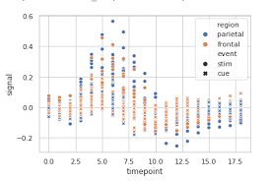

2. Line Plot:

python

sns.lineplot(x='x', y='y', data=data)

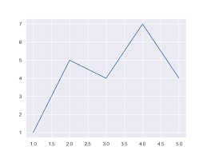

3. Bar Plot:

python

sns.barplot(x='x', y='y', data=data)

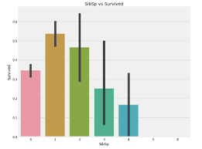

4. Count Plot:

python

sns.countplot(x='category', data=data)

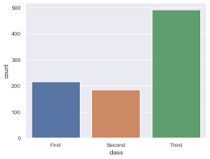

5. Box Plot:

python

sns.boxplot(x='x', y='y', data=data)

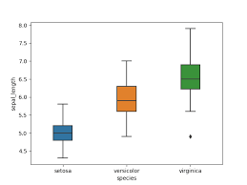

6. Violin Plot:

python

sns.violinplot(x='x', y='y', data=data)

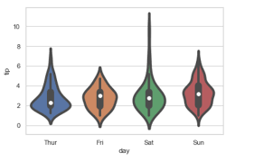

7. Heatmap:

python

sns.heatmap(data.corr(), annot=True, cmap='coolwarm')

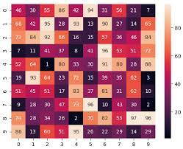

8. Pair Plot:

python

sns.pairplot(data)

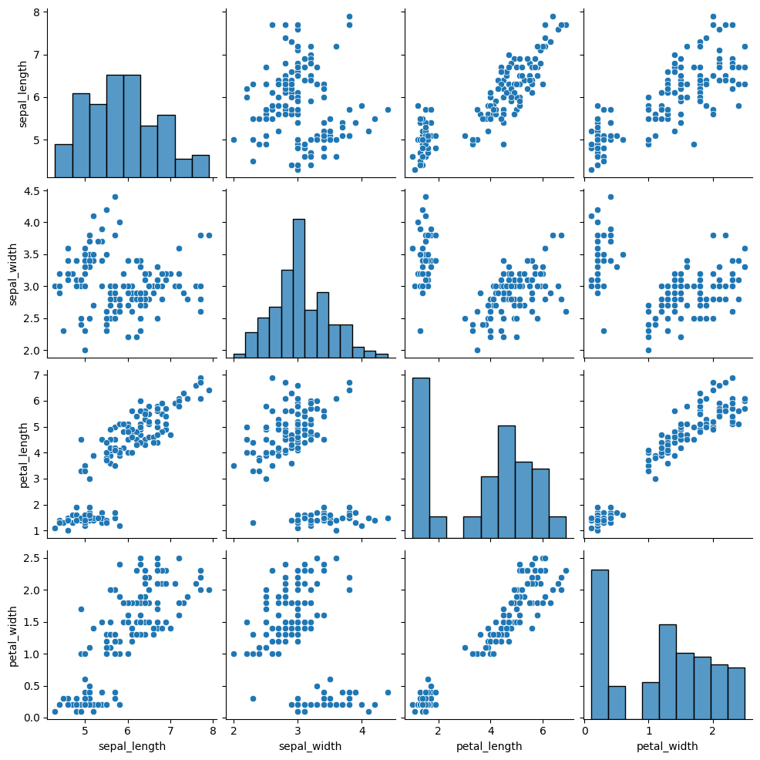

These are just a few examples, and Seaborn offers many more plot types and customization options. Depending on your data and the insights you want to gain, you can choose the appropriate type of plot. Explore the Seaborn documentation for more details and examples: [Seaborn Documentation] (https://seaborn.pydata.org/).